Marriott.com Hotel Web Sites

Residence Inn “New Hotel” Photography

Select the Residence Inn photos you would like to appear on your Marriott.com Hotel Website photo tour. The brand-approved captions shown will be displayed. These photos will not meet the LQA guidelines. E-mail completed form to Design.HWS@marriott.com

PART 1: Hotel Information

Property/Hotel Name: Residence Inn Lubbock Southwest
MARSHA code: LBBRW
Hotel Contact (employee name): Luz Cuevas
E-mail address: luz.cuevas@baywoodhotels.com

PART 2: Image Submission Information

Only select one “Exterior” photo.
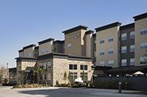

Welcome to the new, all-suite Residence Inn. This photo is a representation of the hotel's facilities and amenities.
ri_new_phototour01

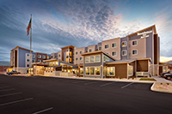

Welcome to the new, all-suite Residence Inn. This photo is a representation of the hotel's facilities and amenities.
ri_new_phototour02

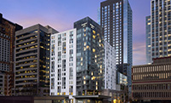

Welcome to the new, all-suite Residence Inn. This photo is a representation of the hotel's facilities and amenities.
ri_new_phototour04

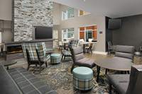

Our modern lobby provides free Wi-Fi and areas to relax, socialize or work. This photo is a representation of the hotel's facilities and amenities.
ri_new_phototour05

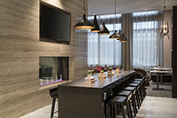

A spacious communal table, located in the lobby, provides guests with room to work, eat or connect. This photo is a representation of the hotel's facilities and amenities.
ri_new_phototour06
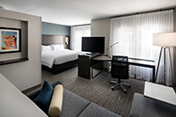

Every room at Residence Inn is a spacious suite with full kitchen. Our studio suites offer distinct areas for working, eating sleeping and relaxing. This photo is a representation of the hotel's facilities and amenities.
ri_new_phototour08
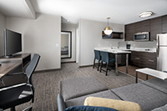

Our spacious one-bedroom suites feature a bedroom and bathroom separated by a door plus a living room, desk and full kitchen. This photo is a representation of the hotel's facilities and amenities.
ri_new_phototour09

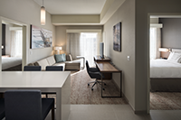

Our spacious two-bedroom suites feature two bedrooms each with their own bathroom. Plus a separate living room, desk and full kitchen. This photo is a representation of the hotel's facilities and amenities.
ri_new_phototour10
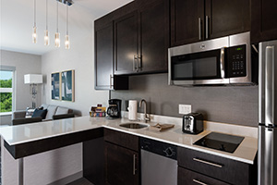

Each suite features a fully equipped kitchen complete with a full-size refrigerator, stovetop, microwave and dishwasher. Plus, enjoy our complimentary grocery delivery service. This photo is a representation of the hotel's facilities and amenities.
ri_new_phototour11
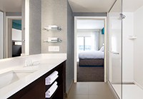

Get ready in style. Our bathrooms feature a contemporary shower design, salon quality amenities from Paul Mitchell, and thoughtful storage such as shelving and abundant drawer space. This photo is a representation of the hotel's facilities and amenities.
ri_new_phototour12
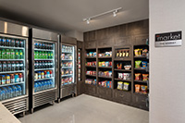

For guests who need to power up on the go, The Market is open 24/7 to provide easy access to a variety of beverages, light meals and snacks, as well as essentials of travel, including toothbrushes, razors and aspirin. This photo is a representation of the hotel's facilities and amenities.
ri_new_phototour14
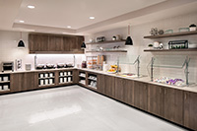
Morning people thrive! Enjoy our complimentary hot breakfast with a variety of healthy indulgent options. This photo is a representation of the hotel's facilities and amenities.
ri_new_phototour15
Only select one “Outdoor Area” photo.
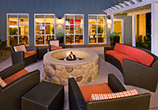

Unwind in our inviting outdoor space with a fire pit and barbeque. This photo is a representation of the hotel's facilities and amenities.
ri_new_phototour17

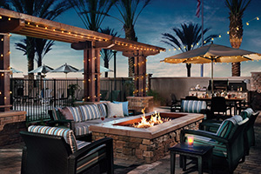

Unwind in our inviting outdoor space with a fire pit and barbeque. This photo is a representation of the hotel's facilities and amenities.
ri_new_phototour23

Only select one “Pool” photo.
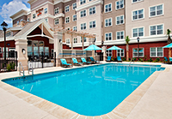

Take a refreshing dip in our beautiful outdoor pool. This photo is a representation of the hotel's facilities and amenities.
ri_new_phototour18
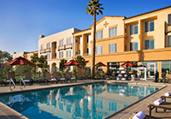

Take a refreshing dip in our beautiful outdoor pool. This photo is a representation of the hotel's facilities and amenities.
ri_new_phototour22
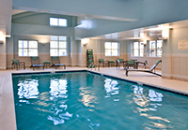

Unwind or swim some laps in our refreshing indoor pool. This photo is a representation of the hotel's facilities and amenities.
ri_new_phototour19

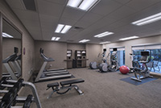

Recharge in our fitness center featuring modern equipment and weights. This photo is a representation of the hotel's facilities and amenities.
ri_new_phototour20

